**SHRI VAISHNAV VIDYAPEETH VISHWAVIDYALAYA**

**SHRI VAISHNAV INSTITUTE OF INFORMATION TECHNOLOGY**

**Project Report**

**on**

HOSTCO

***In partial fulfilment of requirements for the degree***

**of**

**BACHELOR OF TECHNOLOGY**

**IN**

**COMPUTER SCIENCE & ENGINEERING**

***Submitted by:***

LAKSHYA CHAURASIA [21100BTCSAII09426]

ISHAN SHUKLA [21100BTCSAII09420]

LAKSHITA GUPTA [21100BTCSAII09425]

TANSIHA RATHORE [21100BTCSAII09450]

**Under the guidance of**

**PROF. NEERAJ ARYA**



**SHRI VAISHNAV VIDYAPEETH VISHWAVIDYALAYA, INDORE**

**SHRI VAISHNAV INSTITUTE OF INFORMATION TECHNOLOGY**

**DEPARTMENT OF COMPUTER SCIENCE & ENGINEERING**

**JANUARY-JUNE 2024**

**SHRI VAISHNAV VIDYAPEETH VISHWAVIDYALAYA, INDORE**

**SHRI VAISHNAV INSTITUTE OF INFORMATION TECHNOLOGY**

**DEPARTMENT OF COMPUTER SCIENCE & ENGINEERING**

**DECLARATION**

We here declare that work which is being presented in the project entitled “HOSTCO” in partial fulfilment of degree of Bachelor of Technology in Computer Science & Engineering is an authentic record of our work carried out under the supervision and guidance of Prof. Neeraj Arya Asst. Professor of Computer Science & Engineering. The matter embodied in this project has not been submitted for the award of any other degree.



Lakshya Chaurasia



Ishan Shukla



Lakshita Gupta



Tanisha Rathore

**SHRI VAISHNAV VIDYAPEETH VISHWAVIDYALAYA, INDORE**

**SHRI VAISHNAV INSTITUTE OF INFORMATION TECHNOLOGY**

**DEPARTMENT OF COMPUTER SCIENCE & ENGINEERING**

**PROJECT APPROVAL SHEEET**

Following team has done the appropriate work related to the “HOSTCO” in partial fulfilment for the award of Bachelor of Technology in Computer Science & Engineering of “SHRI VAISHNAV INSTITUTE OF INFORMATION TECHNOLOGY” and is being submitted to “SHRI VAISHNAV VIDYAPEETH VISHWAVIDALAYA”.

**Team:**

1) Lakshya Chaurasia

2) Ishan Shukla

3) Lakshita Gupta

4) Tanisha Rathore

**Internal Examiner External Examiner**

Date: 10TH May 2024

**SHRI VAISHNAV VIDYAPEETH VISHWAVIDYALAYA, INDORE**

**SHRI VAISHNAV INSTITUTE OF INFORMATION TECHNOLOGY**

**DEPARTMENT OF COMPUTER SCIENCE & ENGINEERING**

**CERTIFICATE**

This is to certify that Lakshya Chaurasia, Ishan Shukla, Lakshita Gupta and Tanisha Rathore working in a team have satisfactorily completed the project entitled “HOSTCO” under the guidance of Prof. Neeraj Arya in the partial fulfilment of the degree of Bachelor of Technology in Computer Science & Engineering awarded by SHRI VAISHNAV INSTITUTE OF INFORMATION TECHNOLOGY affiliated to SHRI VAISHNAV VIDYAPEETH

VISHWAVIDYALAYA, INDORE during the academic year JANUARY-JUNE 2024

Prof. Neeraj Arya

**Project Coordinator**

Dr. Anand Rajavat

**Director & Head,**

**Department of Computer Science & Engineering**

**ACKNOWLEDGEMENT**

We are grateful to a number of persons for their advice and support during the time of complete our project work. First and foremost, our thanks go to **Dr. Anand Rajavat** Head of the Department of Computer Science & Engineering and **Prof. Neeraj Arya** the mentor of our project for providing us valuable support and necessary help whenever required and also helping us explore new technologies by the help of their technical expertise. His direction, supervision and constructive criticism were indeed the source of inspiration for us.

We would also like to express our sincere gratitude towards our Director **Dr. Anand Rajavat**

for providing us valuable support.

We are really indebted to **Prof. Neeraj Arya**, project coordinator for helping us in each aspect of our academic’s activities. We also owe our sincere thanks to all the **faculty members of** Computer Science & Engineering Department who have always been helpful.

We forward our sincere thanks to all **teaching and non-teaching staff** of Computer Science & Engineering department, SVVV Indore for providing necessary information and their kind co-operation.

We would like to thanks our parents and family members, our classmates and our friends for their motivation and their valuable suggestion during the project. Last, but not the least, we thank all those people, who have helped us directly or indirectly in accomplishing this work. It has been a privilege to study at SHRI VAISHNAV VIDYAPEETH VISHWAVIDYALAYA, INDORE.

**Abstract**

HostCo introduces a cutting-edge cloud-based file management system designed to revolutionize digital asset organization and accessibility. With a focus on user-friendliness and comprehensive features, HostCo offers a secure environment for individuals and businesses to manage their files efficiently. Users can seamlessly register and login to access their personalized dashboard, where they can upload, download, and organize files with ease. The platform supports various file formats, ensuring compatibility for diverse digital assets.

Key features include project management tools that enable users to categorize files, and collaborate with team members or clients. Additionally, HostCo provides robust administrative functionalities, including user and file management tools, as well as the ability to create and manage file categories. The admin dashboard offers insights into system usage, allowing administrators to monitor user activity and maintain an organized file repository.

HostCo's innovative approach emphasizes both security and usability, ensuring that users can manage their files efficiently while maintaining data privacy. By offering a centralized hub for file management activities, HostCo empowers users to streamline their workflows and enhance productivity. Whether for personal use or business applications, HostCo provides a comprehensive solution for effective file management in the cloud.

Upon completion, the project will provide users with a cloud platform to store data and files.

**LIST OF FIGURES:**

Figure 1 – Use Case

Figure 2 – Flow-Chart

Figure 3 – DFD Level 0

Figure 4 – ER Diagram

Figure 5 – Sequence Diagram

Figure 6 – Activity Diagram

**TABLE OF CONTENT**

Declaration I

Project Approval Sheet II

Certificate III

Acknowledgement IV

Abstract V

List of Figures VI

**CHAPTER 1 – INTRODUCTION**

1.1 Introduction

1.2 Problem Statement

1.3 Need for the Proper System

1.4 Objective

1.5 Scope

**CHAPTER 2 – LITERATURE SURVEY**

2.1 Existing System

2.2 Proposed System

2.3 Feasibility Study

2.3.1 Technical Feasibility

2.3.2 Economic Feasibility

2.3.3 Operational Feasibility

**CHAPTER 3 – REQUIREMENT ANALYSIS**

3.1 Method used for Requirement Analysis

3.2 Data Requirements

3.3 Functional Requirements

3.4 Non-functional Requirements

3.4.1 Performance Requirements

3.4.2 Security Requirements

3.4.3 Software Quality Attributes

3.5 System Specification

3.5.1 Hardware Specification

3.5.2 Software Specification

**CHAPTER 4 – DESIGN**

4.1 Software Requirement Specification

4.1.1 Glossary

4.2 Use Case Model

4.3 Flow-Chart

4.4 DFD Level-0

4.5 ER Diagram

4.6 Sequence Diagram

**CHAPTER 5 – SYSTEM MODELING**

5.1 Activity Diagram

**CHAPTER 6 – CONCLUSION & FUTURE WORK**

6.1 Conclusion

6.2 Limitations of Project

6.3 Future Enhancement

**CHAPTER 7 – BIBLIOGRAPHY & REFERENCES**

7.1 Reference Books

7.2 Other Documentation & references

**Project Snapshots:**

**User Section**

* **Home**

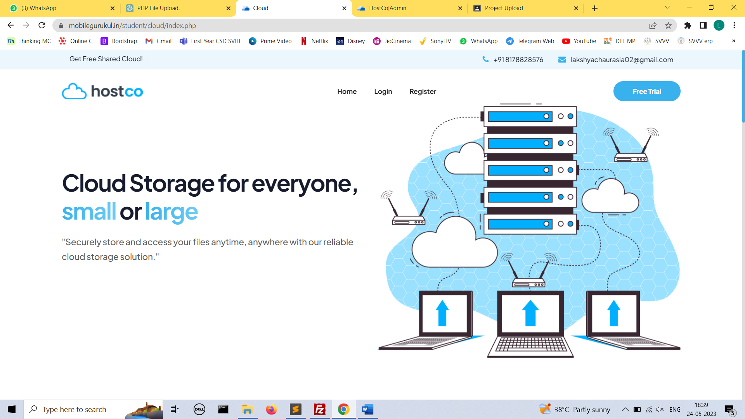

* **Login**

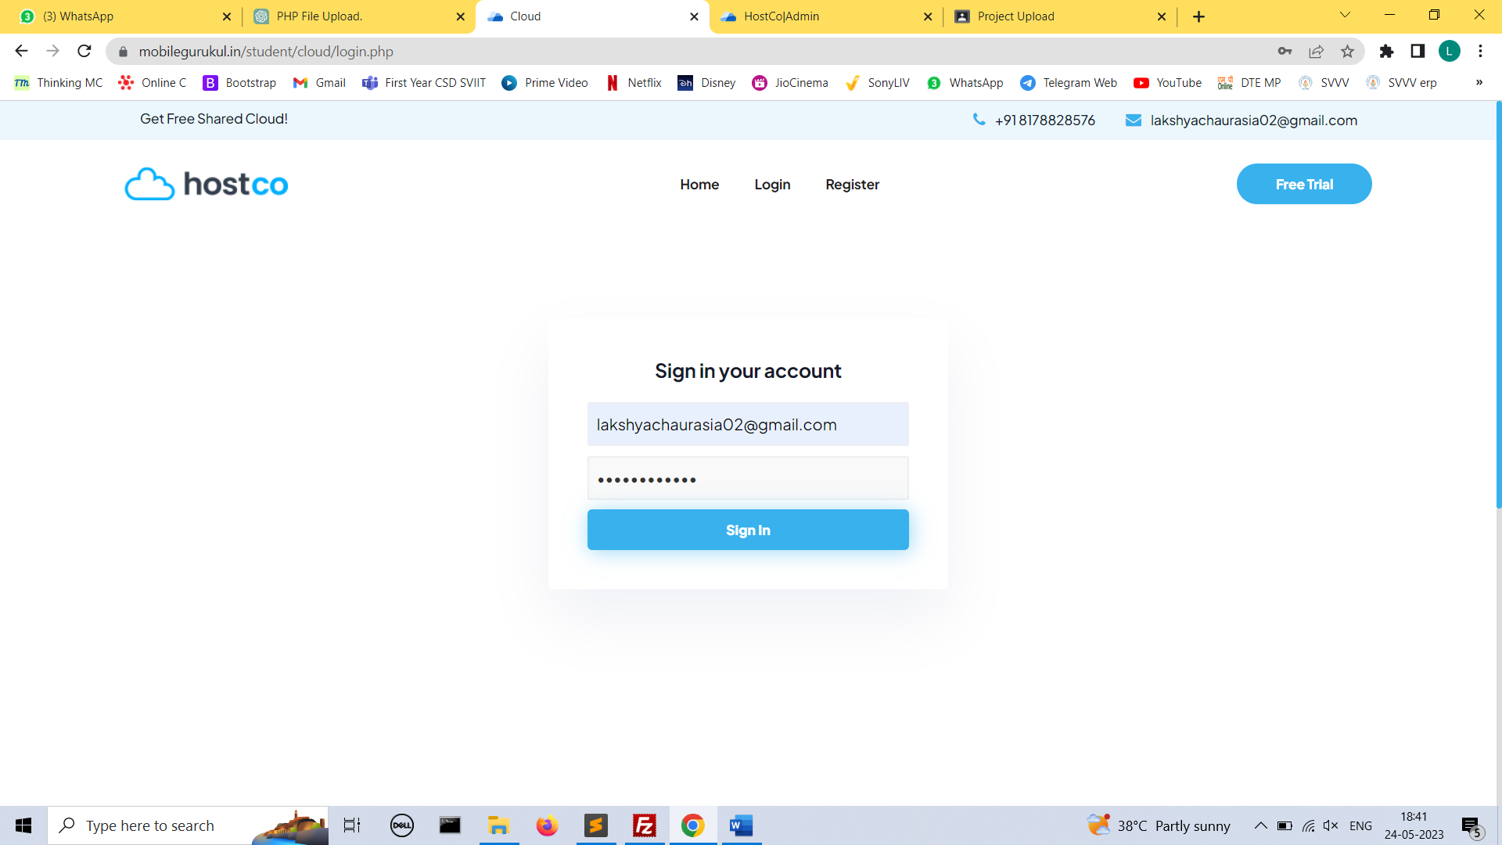

* **Register**

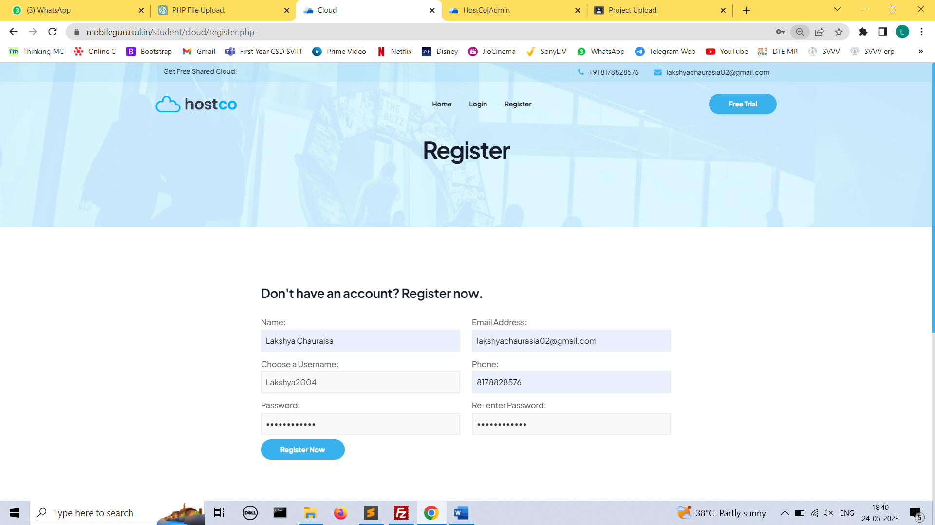

* **Dashboard**

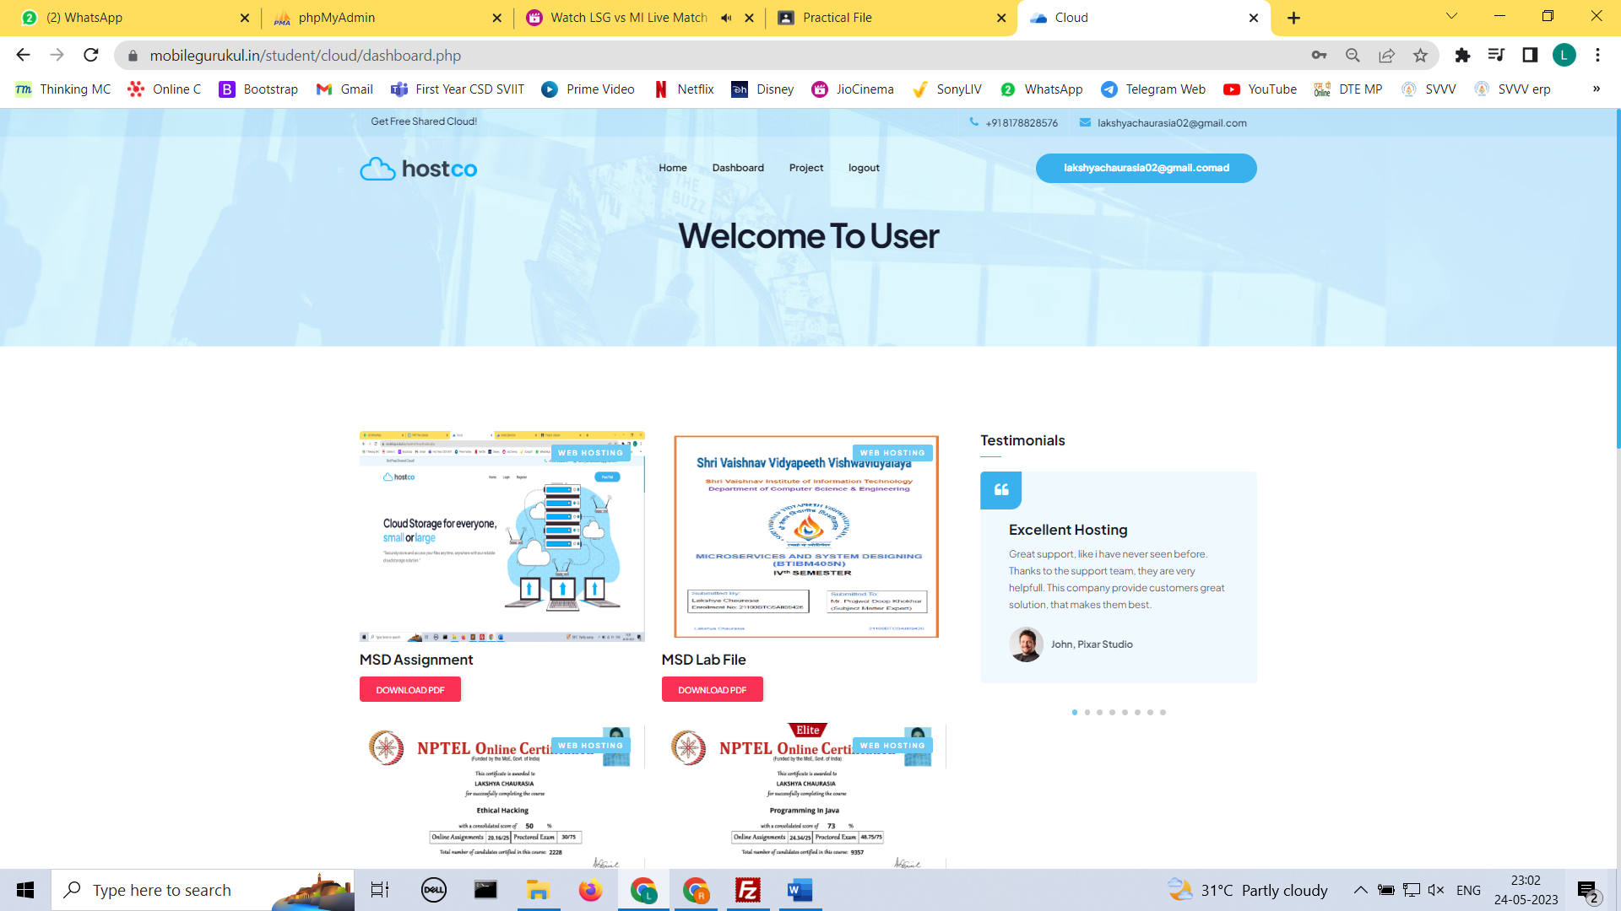

* **Projects**

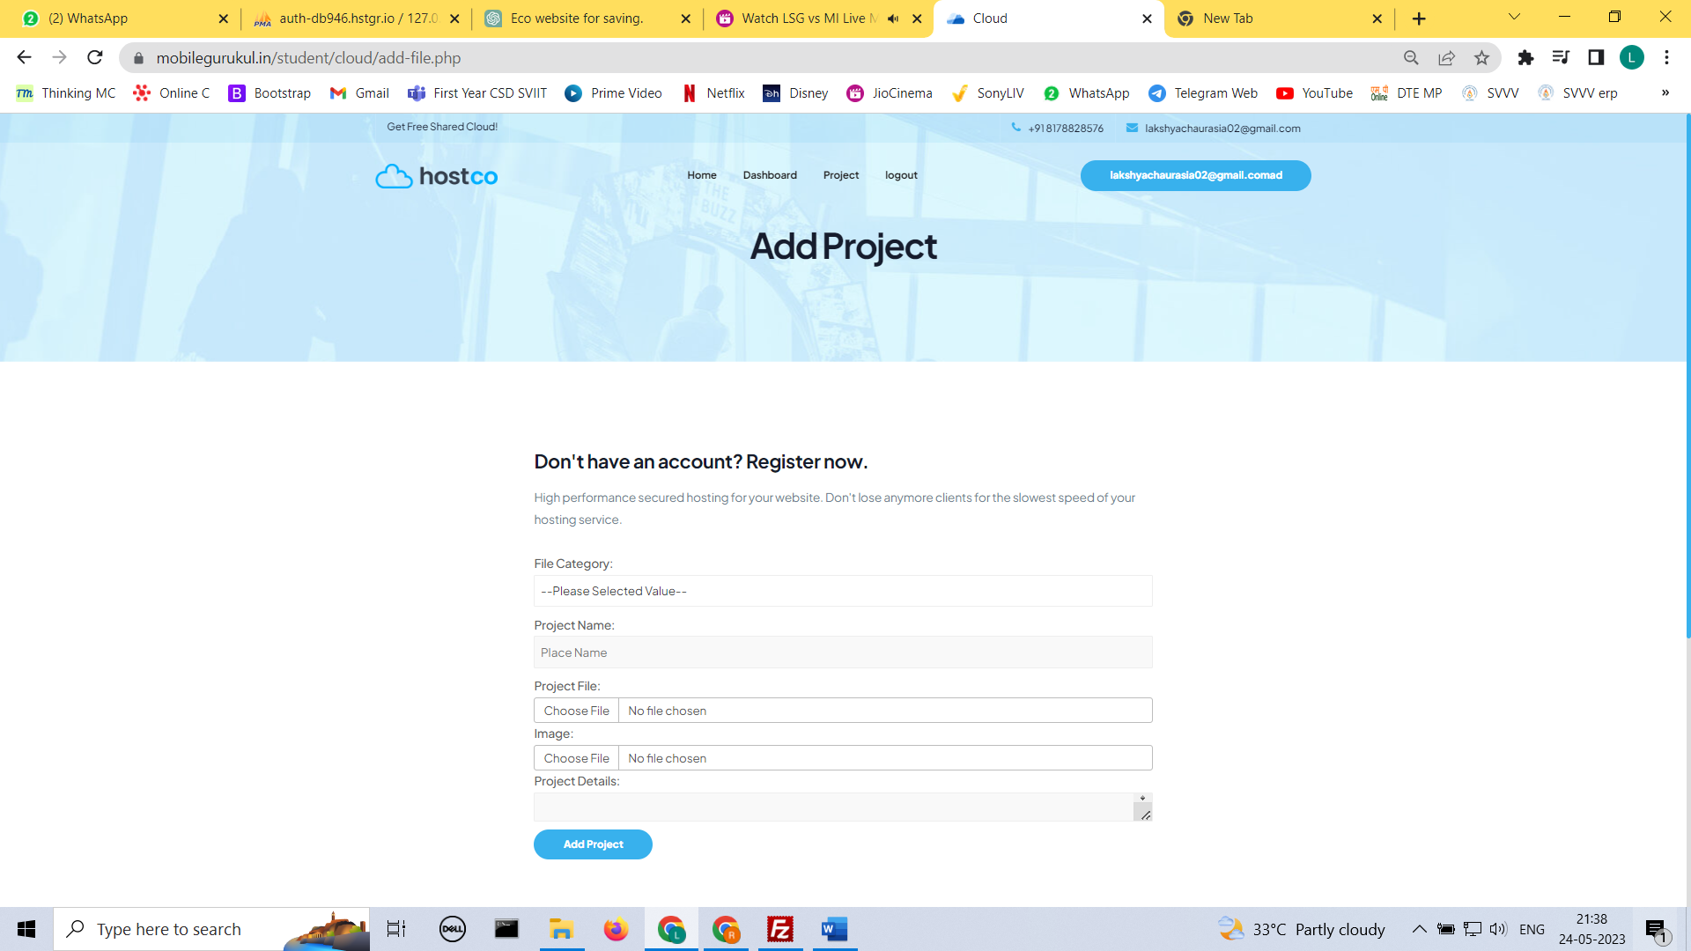

**Admin Section**

* **Login**

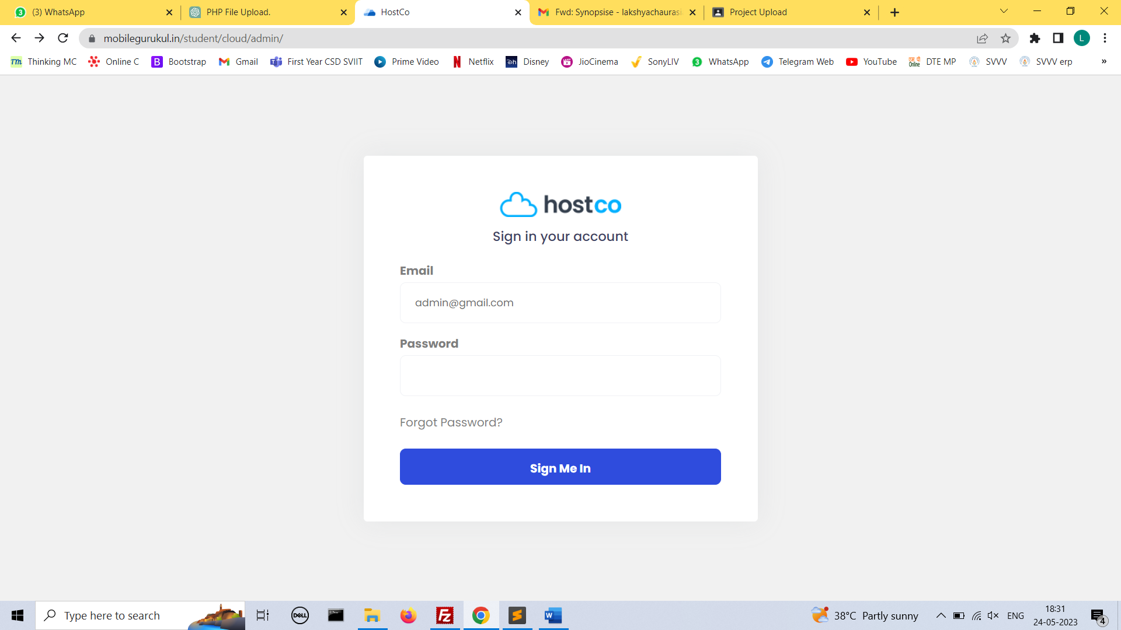

* **Dashboard**

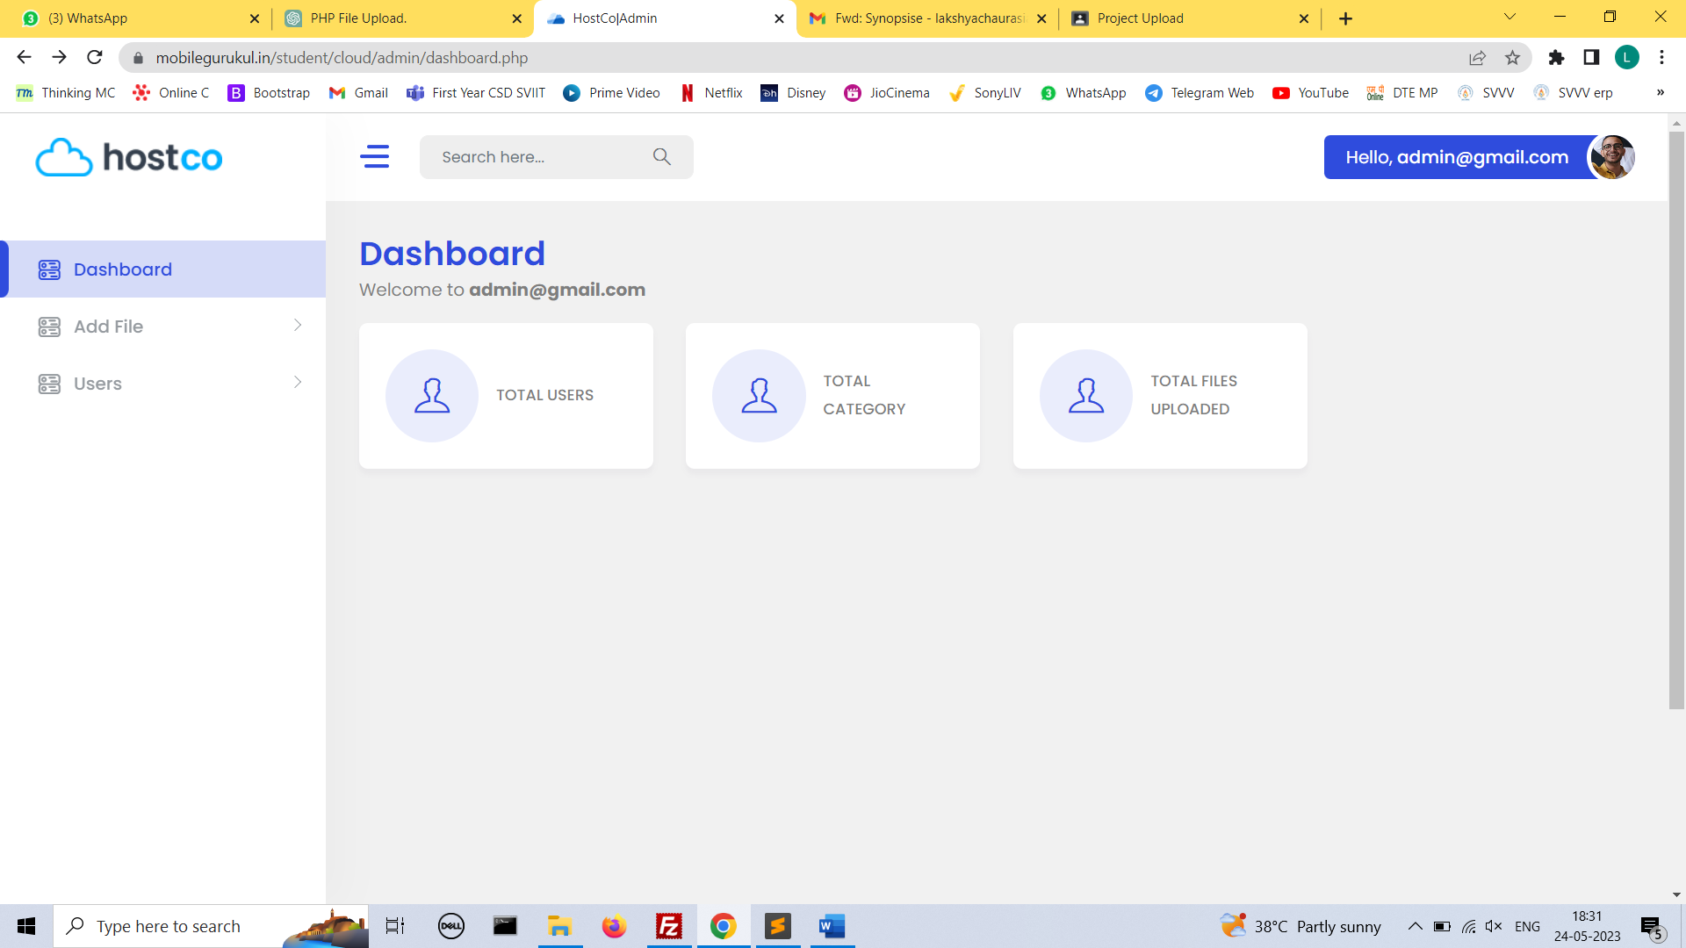

* **Add File**

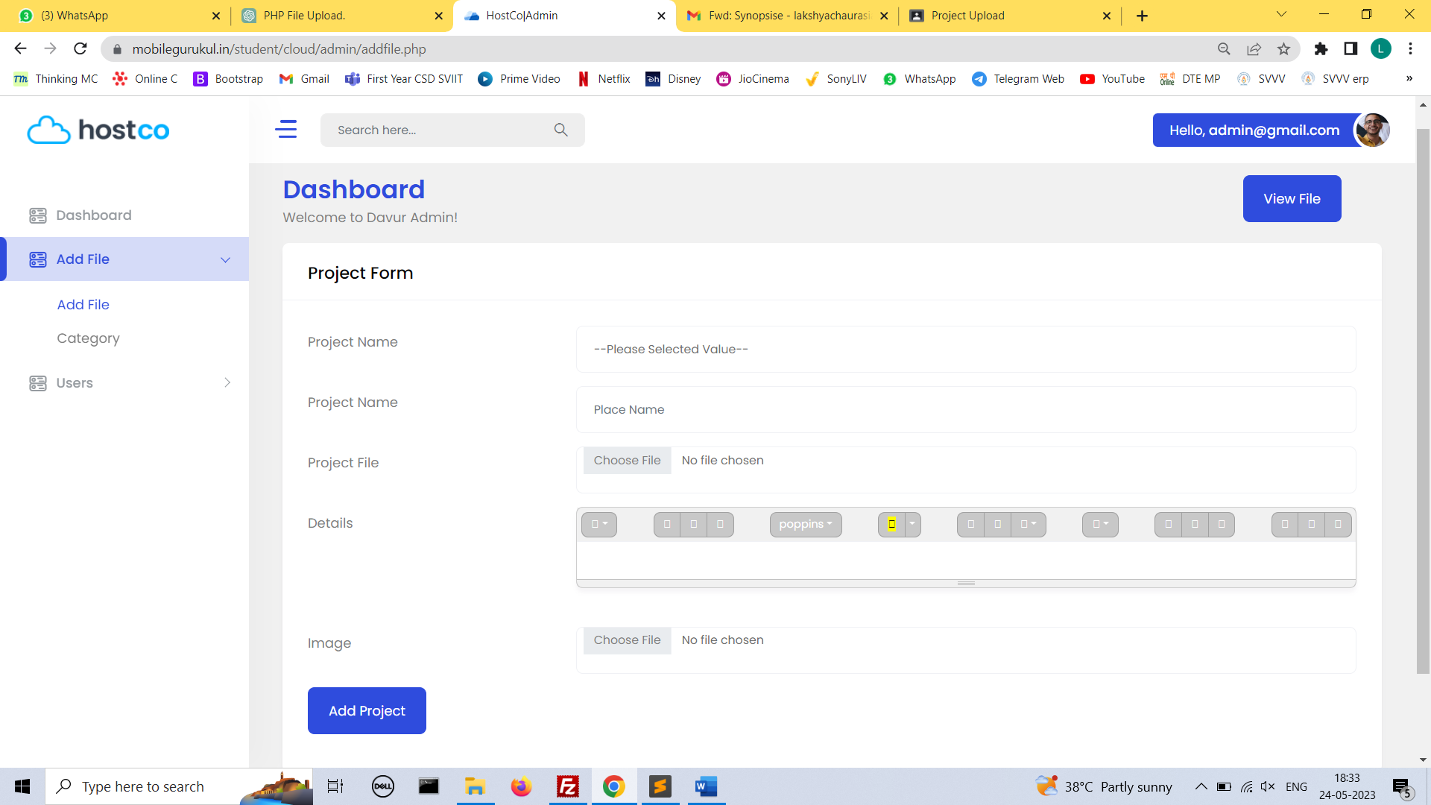

* **View File**

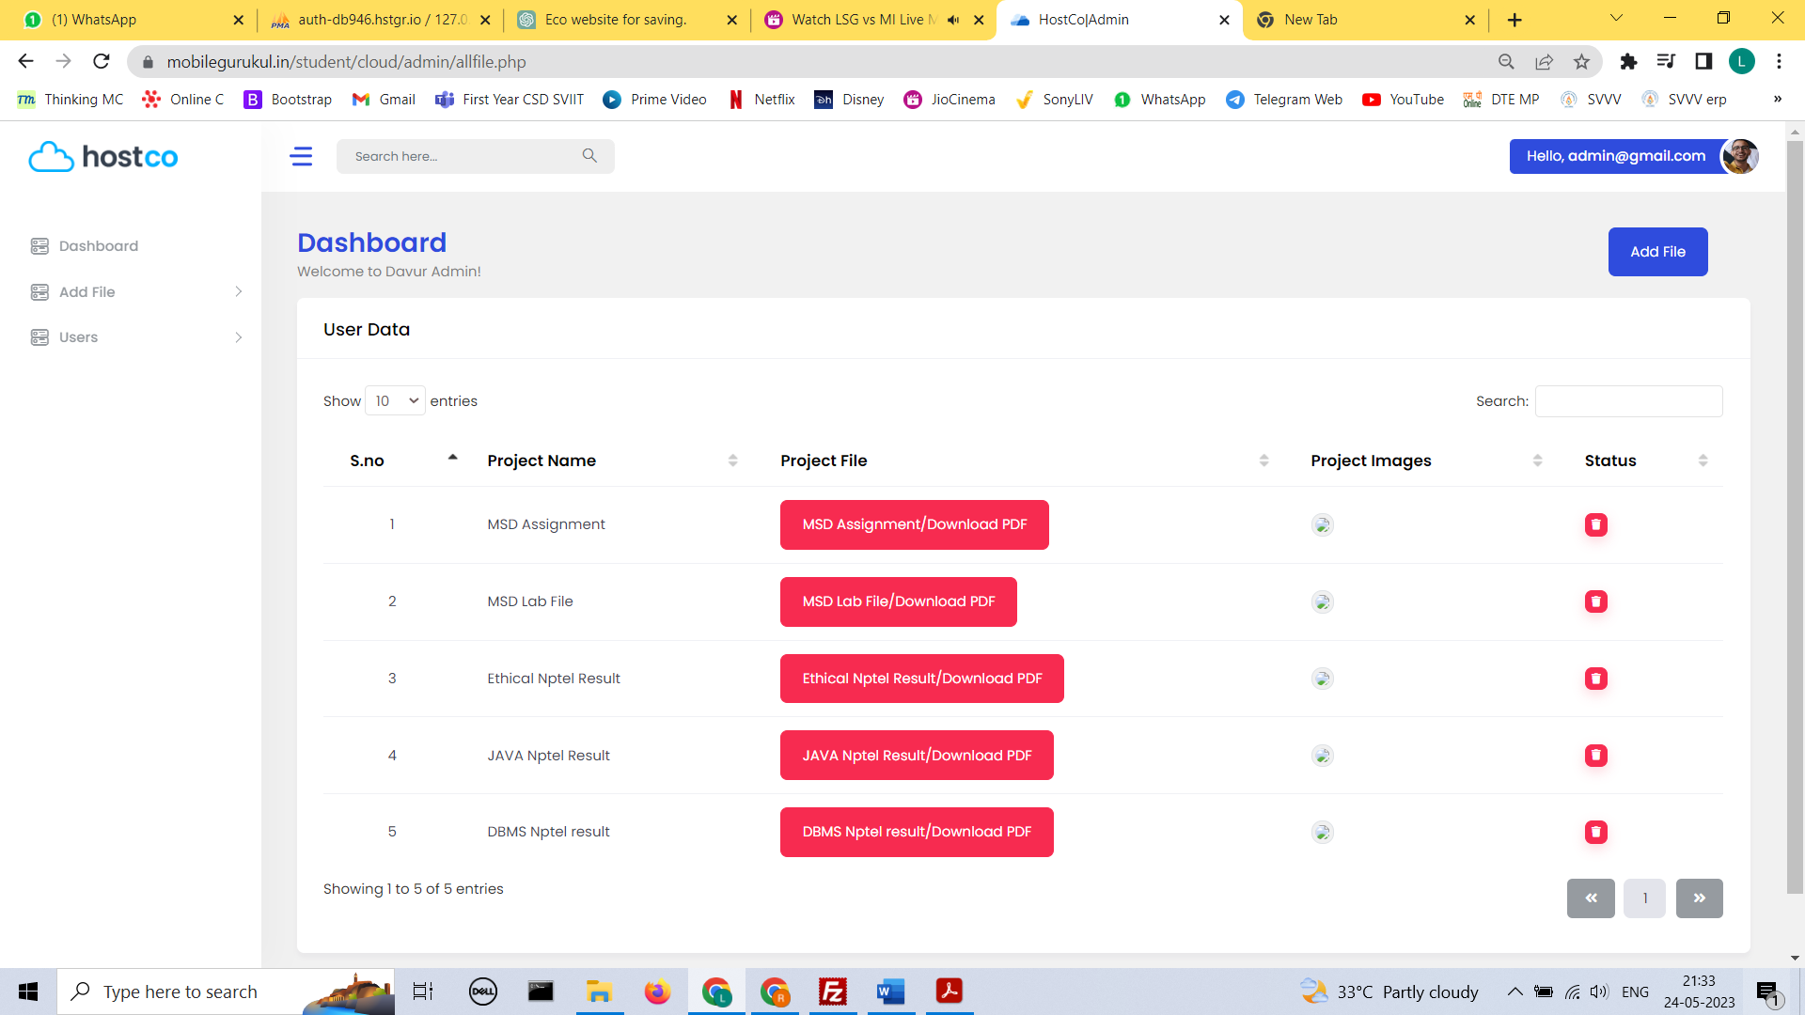

* **Category**

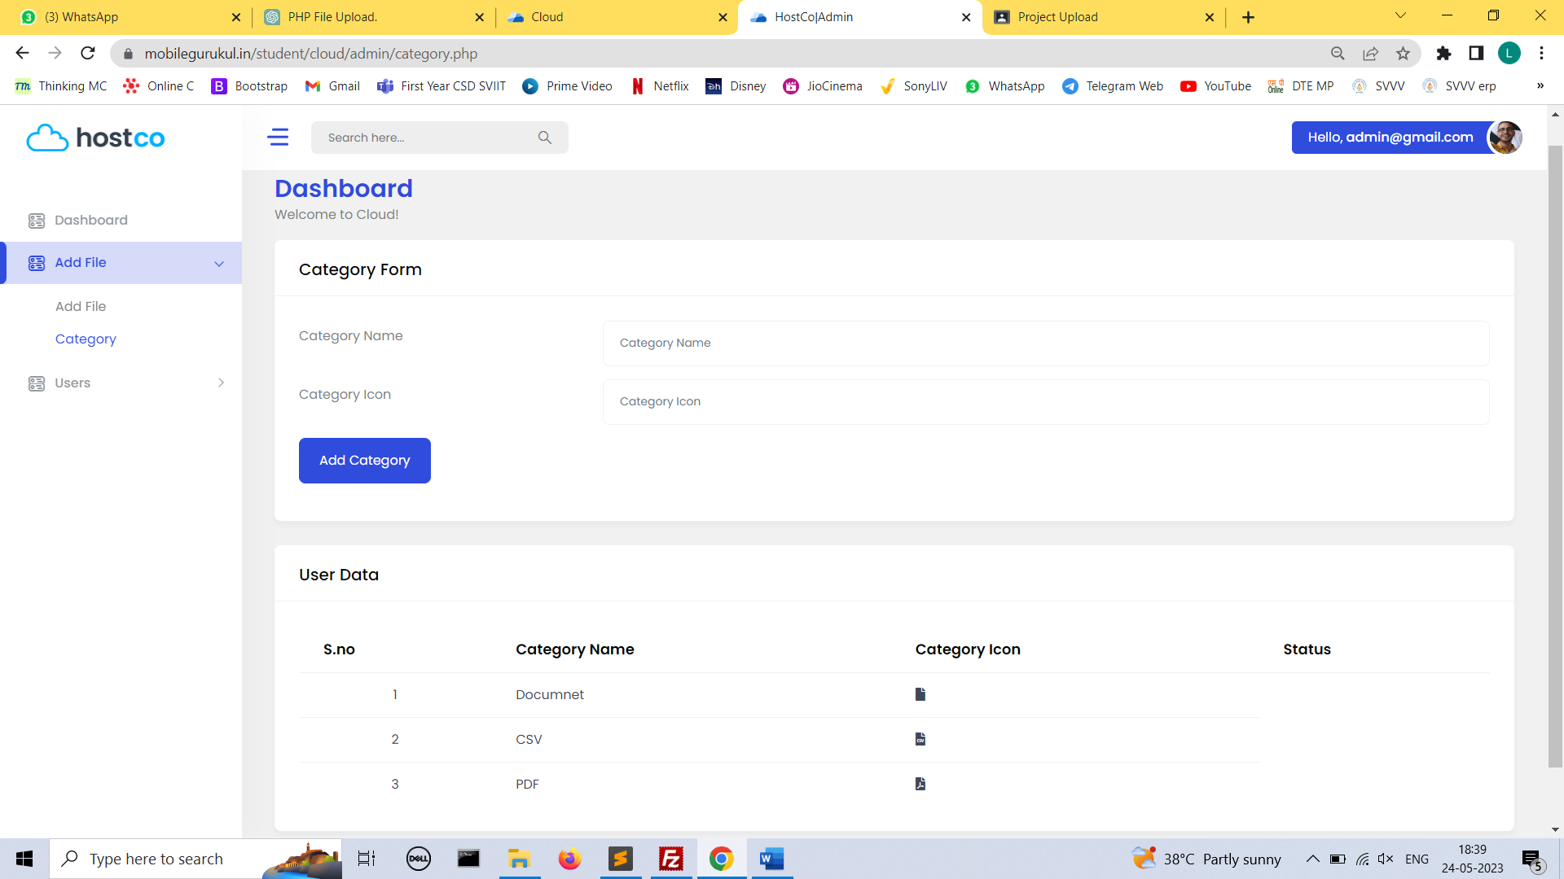

* **Users**

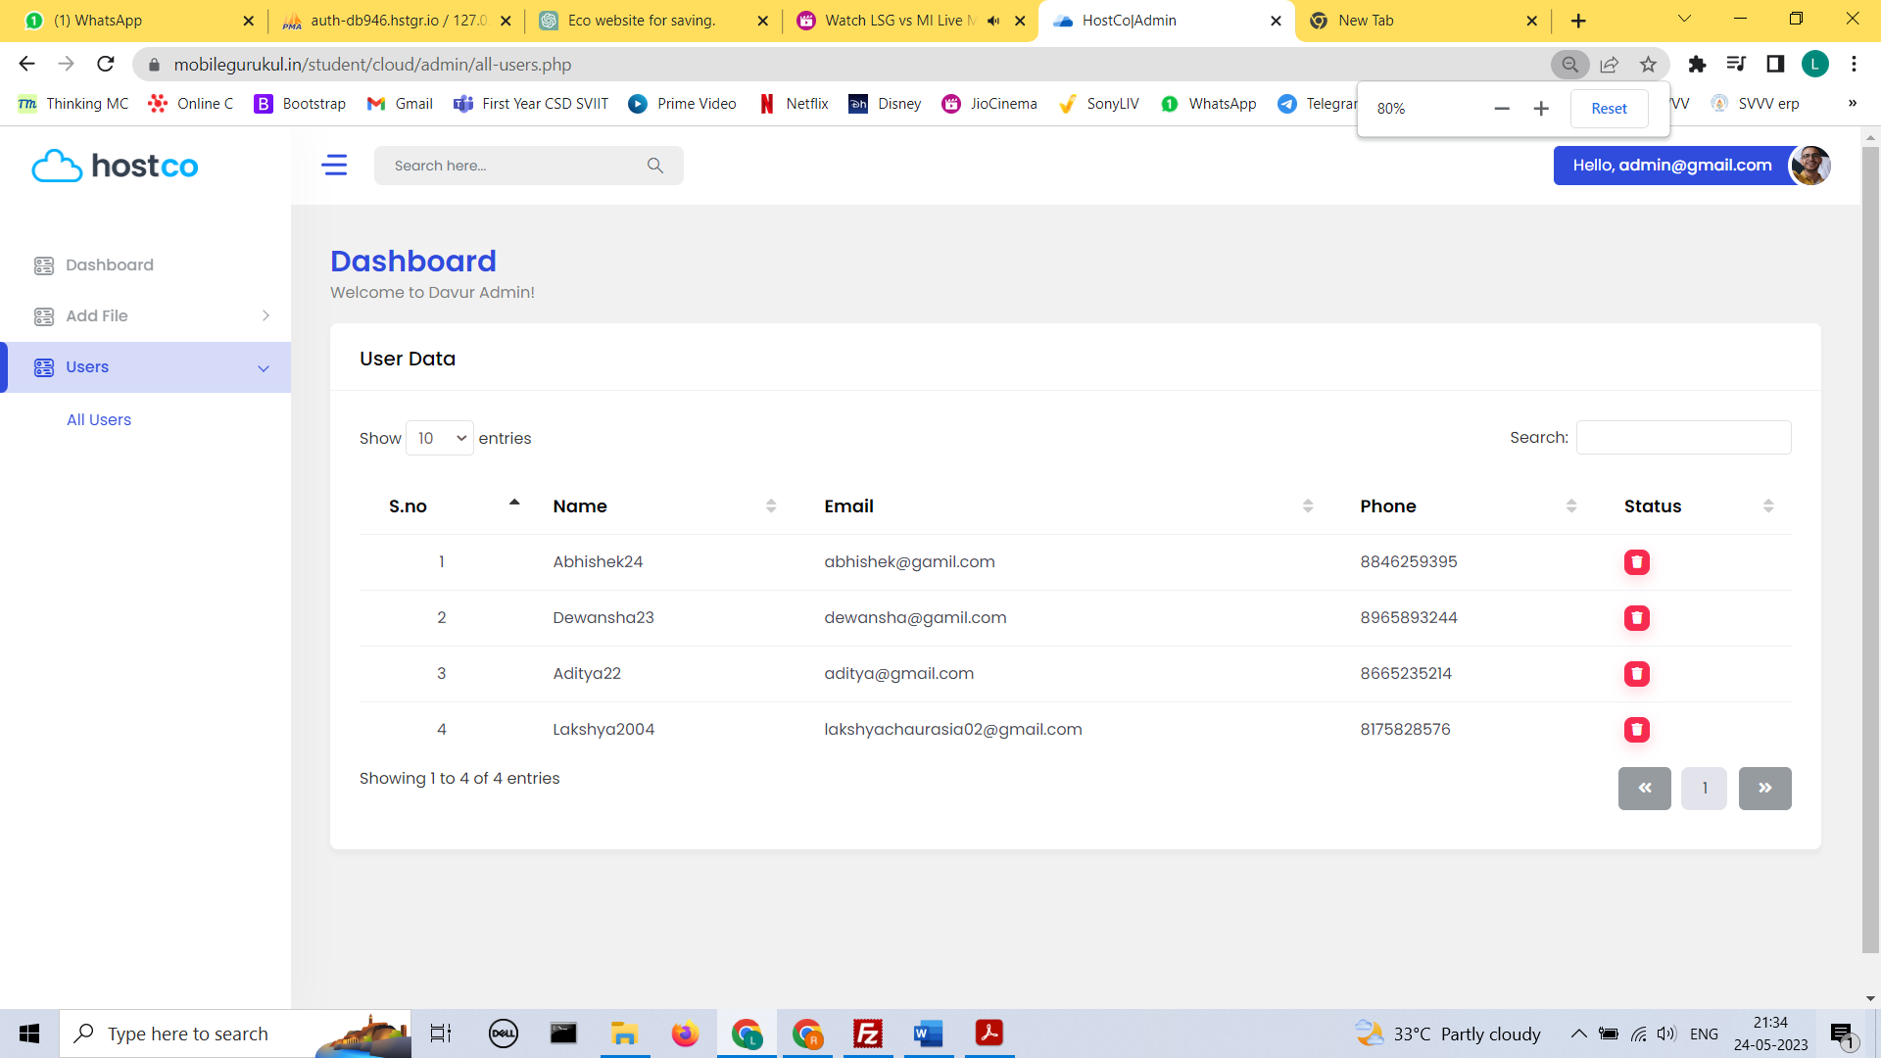

**Database**

